**User Manual**

**Project name : Digital University**

**Module Name: University Budget Management**

Founder, Framework and Architecture:

Dr. KAZI MASUDUL ALAM

Assistant Professor

CSE Discipline

Khulna University

Developed By :

Uttam Paul (160236)

Israt jahan Joya (160239)

Login Page

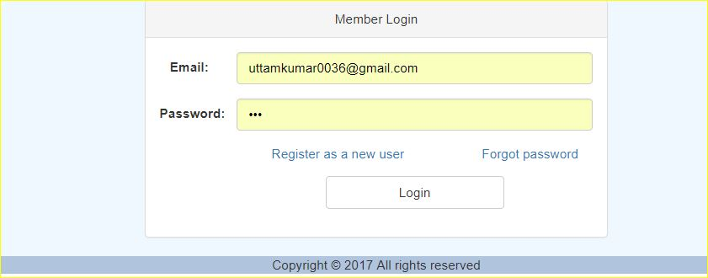

Home page

Admin pannel

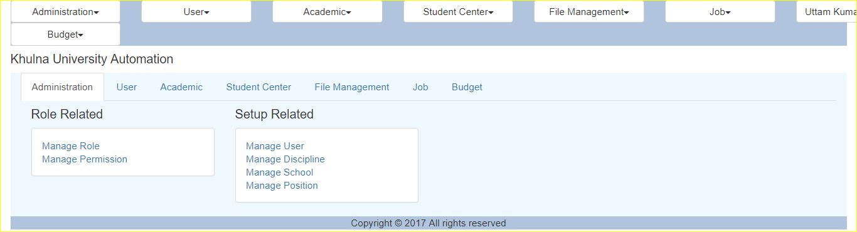

**Admin can access “Budget” “Budget information” “manage Budget information” Option.**

**User can access “Budget information” option.**

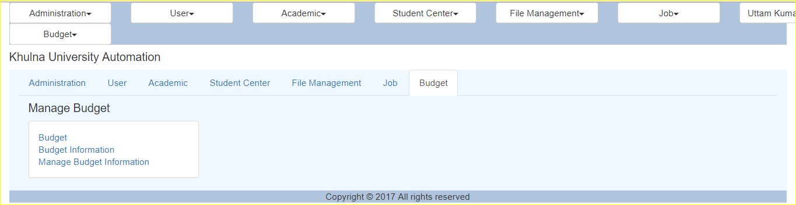

Budget Information Page

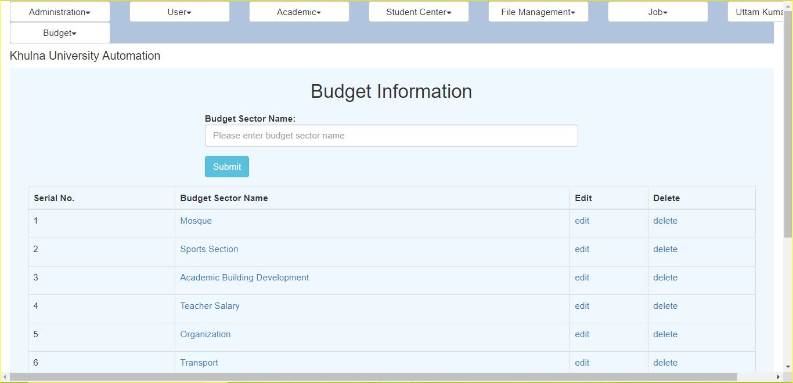

Edit budget Sector Name

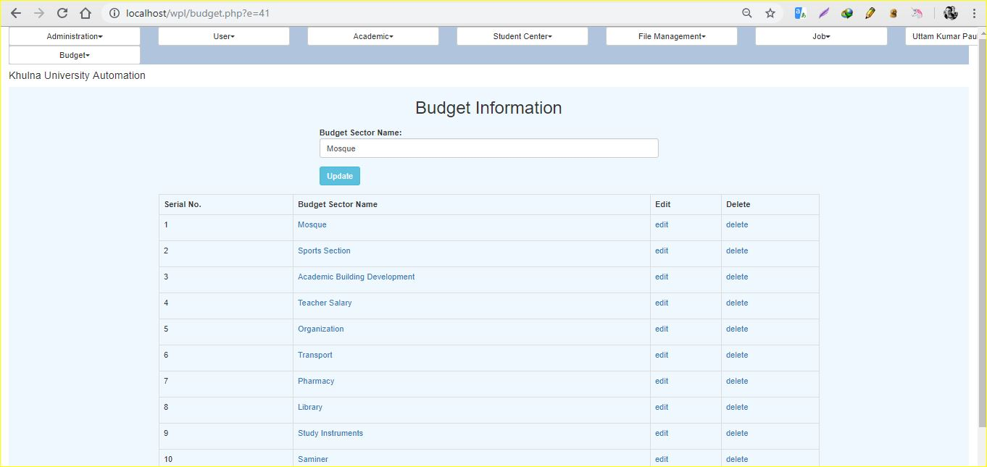

Show Budget information on click this sector

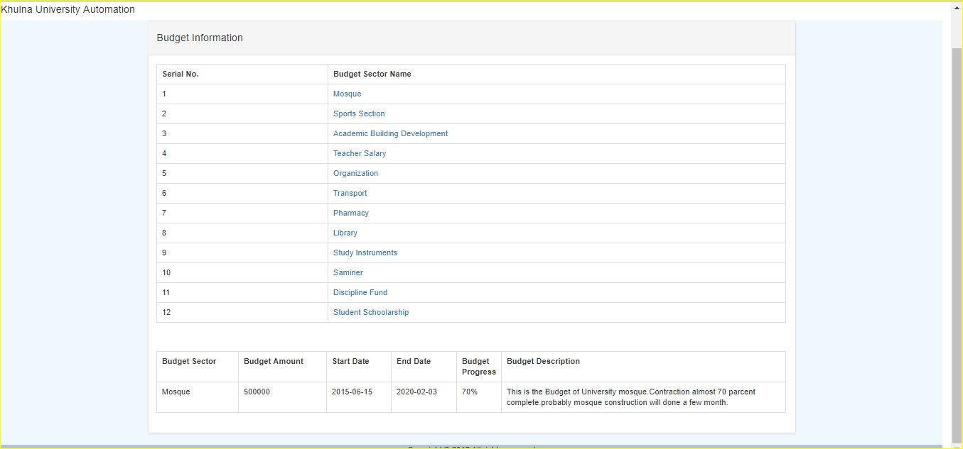

Manage budget information

Add information only Admin

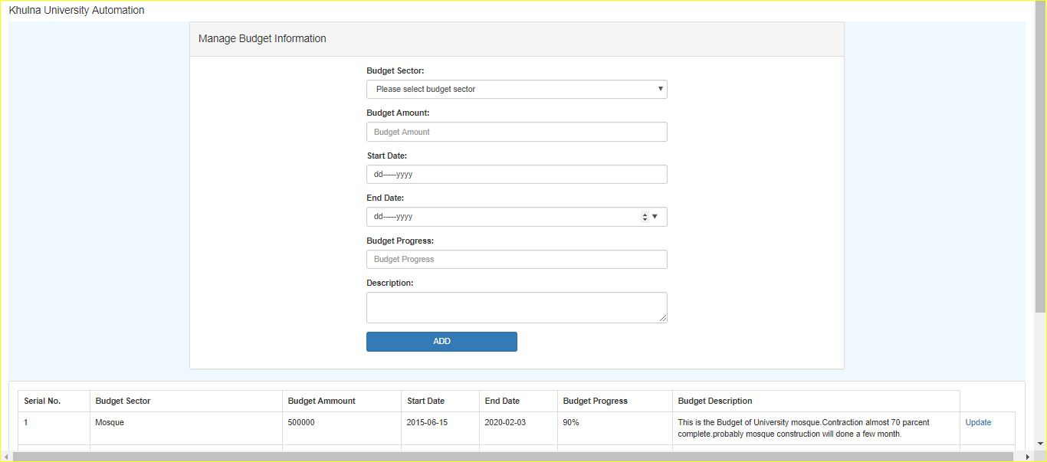

Details all Budget Information

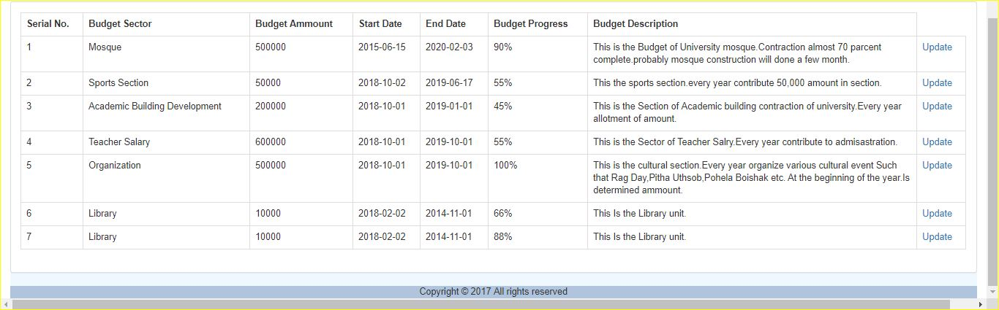

Budget Information Update

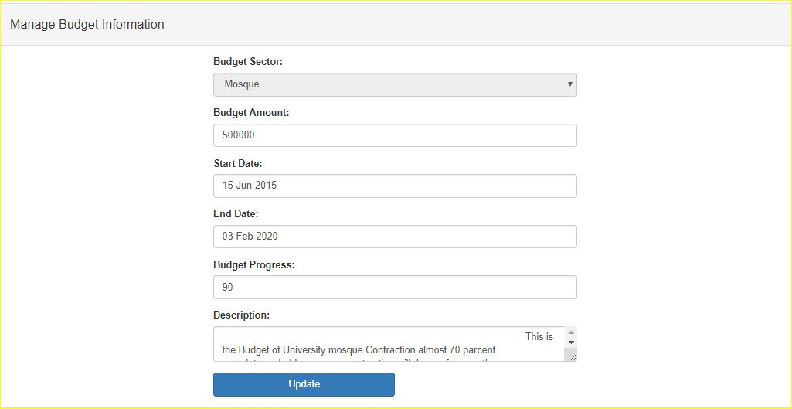

User panel

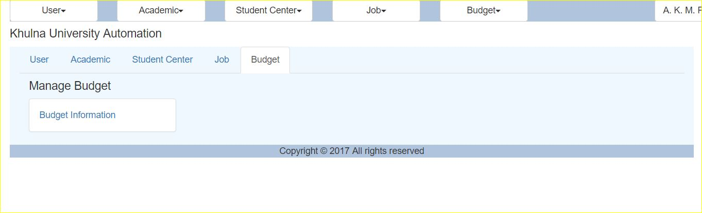

Budget Information page

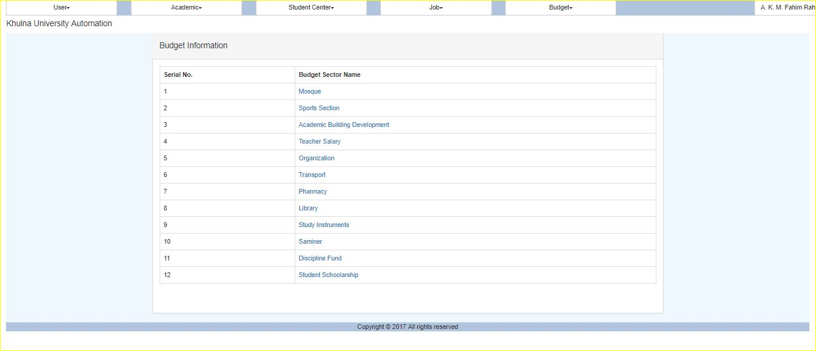

Show Up Details Information

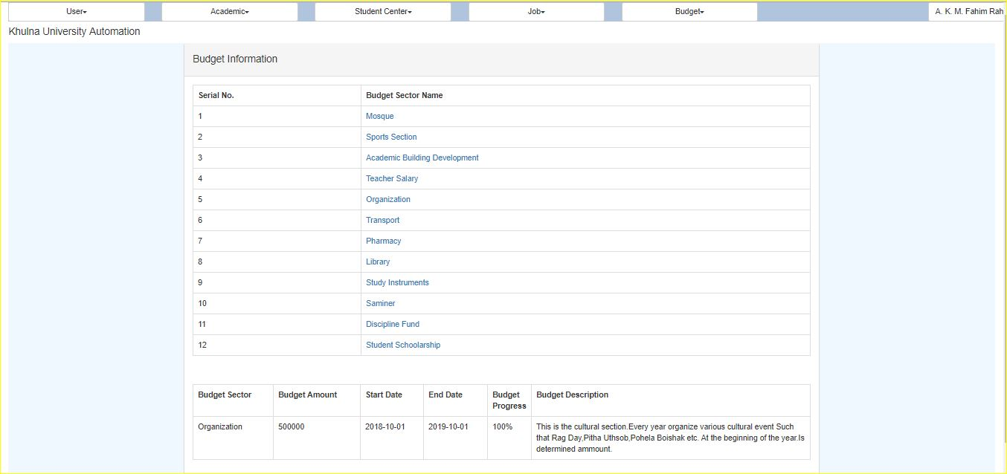

Thank You